Course Code: HTTP-5101 ONA
Date: 27-Sep-2017
Student Number: N01259168
Name: Diego Moncada

4)
1. SQL Plus
2. SQL Developer script

5)
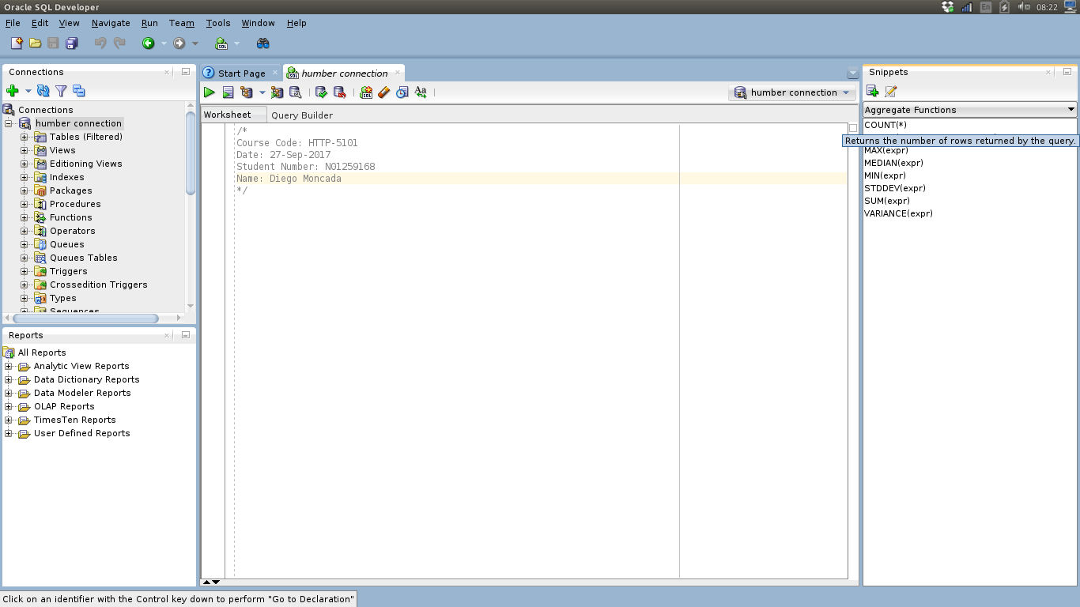
6)
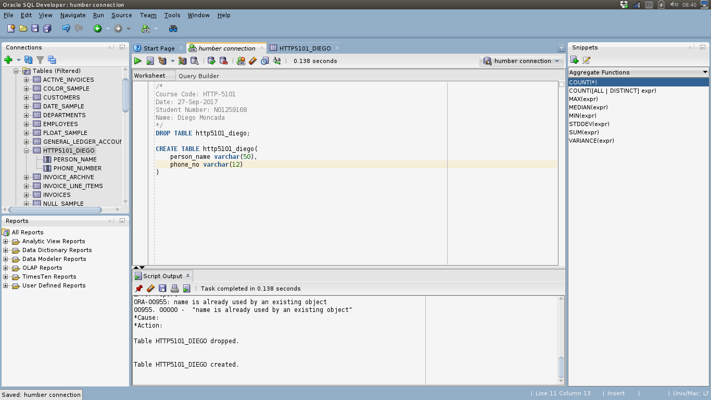
7)
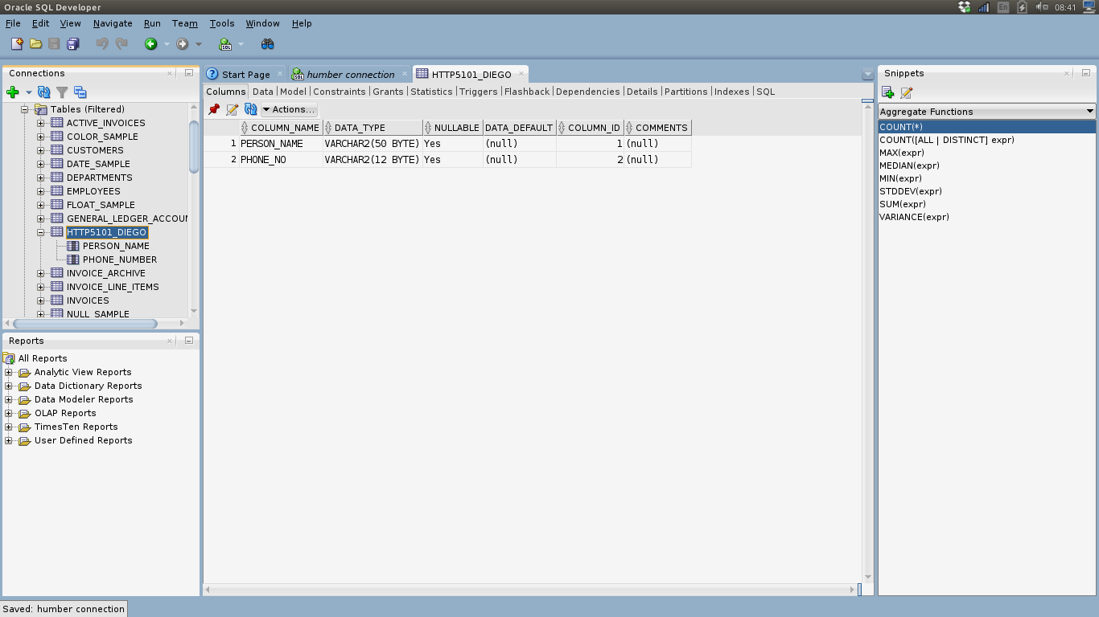
8)Row: one set of values in one table. This set of values have one value for every column defined (even though this value can be null)
Column: is the types of values or “spaces” I can insert in to a table in each row.
DDL: Database definition language.
DML: Database management language.

9)
Delete: is used to erase 1 or more rows of a certain table.
Insert: is used to add new rows with values to a table.
Select: is used to do querys to a databes. With these, you can do querys and get the information you want in the way you want it (you can choose what to see, from which tables, that fulfills certain conditions and in any order you want).
Update: is used to change values of 1 or more rows of our tables.

